

Training Manual (library & scheduling)

Training Manual (library & scheduling)

OPAS: The Orchestra Planning & Administration System

Distributed and supported by Artifax Software Ltd. in the UK

Introduction
This training manual covers the Library and Scheduling features of OPAS, which you may have covered in your training. Use it as a guide to best practice when first using the system, and as a handy reference as your skills develop. If you find that you require further guidance, Artifax Software Ltd. will be happy to assist, and our contact information can be found on the front cover.

Orientation
OPAS is capable of storing not only a wealth of information, but also manages the intricate links between data. Orchestra administration is necessarily complex, however the uniformity of the various screens means that navigation and the entering of data is straightforward once you are familiar with a small set of conventions.

This diagram explains the features and icons found on most screens in OPAS:

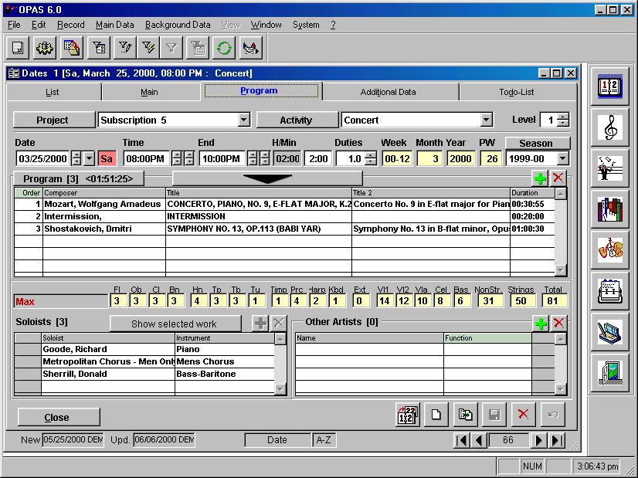
a

b

c

d

e

m

f

g

h

k

i

j

l

A – Function Icons
These function icons appear on all screens. Most items have a keyboard equivalent (indicated in parenthesis) and are, from left to right:

REPORTS (F4) Opens the report window and displays the available reports for that section.
FUNCTIONS This is for programming use only. It enables Artifax Software Limited to send an Orchestra-specific routine to run on your personal copy of OPAS to manipulate data, run updates, etc. DO NOT run anything from this screen unless you have been specifically advised.
EXPORT DATA Opens the Export Data window, allowing you to export data from the current Section or Window of OPAS into a variety of digital formats
ADVANCED FILTER (F5)
Opens the Advanced Filter window
EDIT FILTER (F6) Places OPAS into the Intermediate Filter mode
FILTER BY SELECTION (F7)
Executes a Basic Filter – active only from List Tabs
APPLY FILTER (F8)
Executes an Intermediate Filter once you have entered the criteria
SHOW ALL RECORDS (F9)
Clears the results of any filter, and displays all records in the Section
REFRESH (F10) Refreshes the current screen with the most recent data
RELATED DATA (F11)
Displays a list of related sections of OPAS. Choosing one of those sections will load it with the currently active data

B – Title Bar
The Title Bar will display different information depending upon the OPAS Section. The first Word(s) is always the Section name, followed by the details of the currently active record.

C – TABS
Each Section in OPAS is divided into Tabs. The currently active tab will display in Blue

D – Field Captions
Some field captions in OPAS are actually buttons (such as Project and Activity on the screen shown here). Clicking the Field Caption Button will load the background data for that field.

E – Yellow-Tinted Fields
Some fields in OPAS will be tinted yellow (such as Week, Month, Year and PW on the screen shown here). A yellow-tinted CD indicates that the field is calculated or dictated from another OPAS section and cannot be edited by the User.

F – Grids
Grids are used throughout OPAS to store multiple pieces of data (such as works on a program). To add a data item, click the green “+” icon at the upper right of the grid. To remove an item, select it and click the red “x”. If a column heading in any grid is light green, that indicates that the contents of that column can be edited by the User. You can sort a grid based upon the contents of any column whose heading is light green. To edit a line in a grid, double-click on it. To see related sections of OPAS, float the mouse cursor in the Grid, and Right-Click your mouse.

G - Close / OK / Cancel Buttons
These buttons appear in different combinations throughout the various sections of OPAS. “Close” = close this section. “OK” = save any changes, close this section, and load the (saved) changes into the originating section. “Cancel” = do not save changes, and return to the originating section.

H – Operation Icons
These buttons appear on every section of OPAS.

COPY DATE Open the Copy Date window to copy the current date/activity to another date.
NEW (CTRL + N) Create a New Record in this section
NEW + COPY Create a New Record in this section, based upon the main data from the current record
SAVE (CTRL + S) Save the current record
DELETE (CTRL + D)
Delete the current record
RESTORE (CTRL + R)
Restore any unsaved changes

I – NEW & UPD
The New field indicates the shorthand Code of the OPAS user who created this record and the day on which it was created. The Upd. field displays the shorthand Code of the OPAS user who last updated this record, and the date it was updated.

J – SORT INDICATOR
This displays the field on which the current section is sorted, and the type of sort.

K – NAVIGATION ICONS
The number in the middle of these icons indicates the number of currently active records in the Section. The arrows surrounding the number move forward and back one record at a time. The far arrows move to the first and last record.

L – SYSTEM INDICATORS
The first box is inactive. The second indicates if your NUMBERS LOCK is on (NUM appears in the box). The third indicates if your CAPS LOCK is on (CAPS appears in the box). Your computer’s system time also appears here.

M – SECTION ICONS
These icons open the various main sections of OPAS. The sections are, in order from top to bottom: Calendar, Works, Composers, Library, Artists, Address Book, Dates and Exit.

Scheduling

Scheduling of your Orchestra’s activities in OPAS is organized into two primary sections:

- The Calendar section which shows an overview of orchestral activities,
- and the Dates section which displays the details of these activities.

CALENDAR

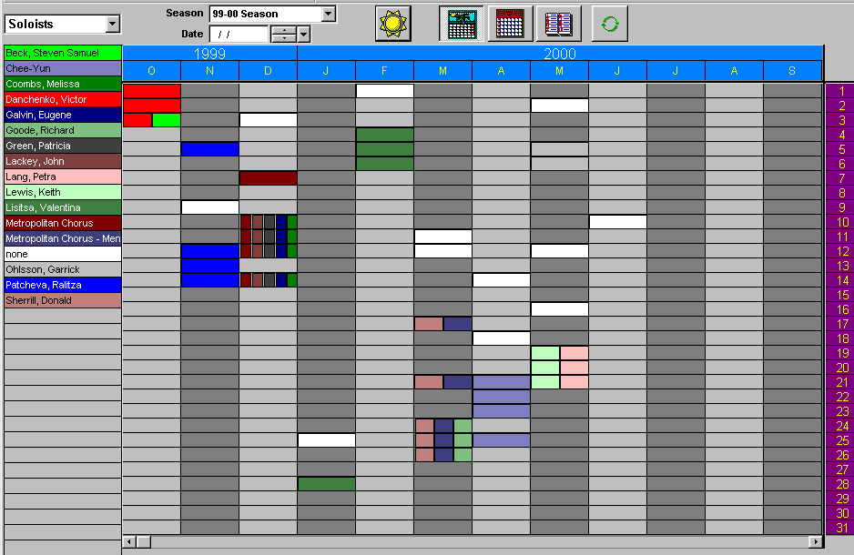
The calendar page will open in the Year View:

The Calendar is organized as follows:

- The Large buttons along the top right side bring up different views:
Year, Month and Week The last button is the Refresh button that will update your screen to reflect any changes.
- You can go to any season by selecting it from the drop-down box in centre of the screen.
- You can go to any date by typing it in the Date box. The drop-down arrow produces a calendar to help you navigate.
- The drop-down menu on the left-hand side (the one that says “Soloists” in the picture above) allows you to view your orchestra’s activity by several different attributes: Venue, Activities, Conductors, Soloists, Projects, Series and Orchestras. Note that as you change from view to view, the bars on the calendar do not move - the concerts and rehearsals stay where they are - but the bars change by colour or size, according to the characteristics assigned to these attributes.
- Note also that as you float the mouse cursor over any bar, the pertinent information for that concert “pops up.”

DATES SECTION

This Dates Section is divided into five areas or sub-sections. As you will see throughout OPAS, each of these sections is represented by a Tab along the top of the Section’s window. The Dates Section has five tabs:
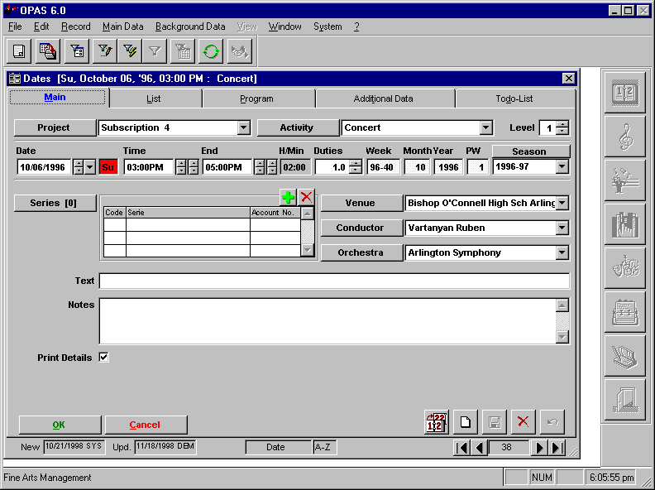

TABS:
- List
- Main
- Program
- Additional Data
- Todo-List

LIST TAB

The List tab is used in all sections of OPAS, and provides a consolidated inventory of the entire section’s contents. In the Dates section, that means all the Activities in the OPAS database. All of your Orchestra’s rehearsals, concerts, auditions, run-outs, etc. are contained here.

The columns on the screen can be:
- resized (float the mouse cursor between column headings and drag to the right or left)
- re-ordered (click on a column heading and drag it to the right or left)
- re-sorted (click on a column heading to sort the list by the contents of that column. The List tab sorts by Date as a default.)

To see the details of any one activity, click the mouse once anywhere in that row, then click the Main Tab at the top of the window. Or, you can simply double-click the mouse anywhere in the row.

MAIN TAB
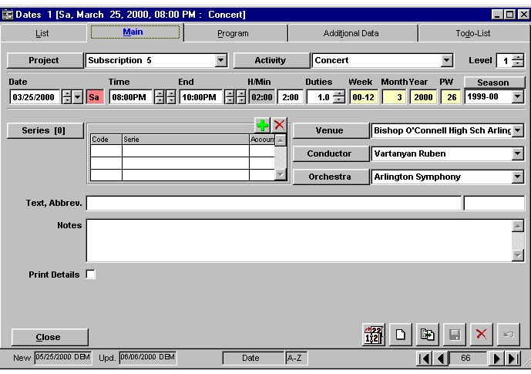
The Main Tab contains the vital information for a concert such as the time, location, and conductor.

Project allows you to organize your orchestra’s events by project (subscription week, recording, tour, outreach, etc.) You will select the appropriate Project from drop-down lists of items that you define.
Activity indicates the specific event (Rehearsal, Dress Rehearsal, Concert, Audition, Sectional, Meeting, etc.) Note the field labels “Project”, “Activity”, “Season”, “Venue”, etc. are also buttons. Clicking them will allow you to edit, create, or delete the items that appear when you click the drop-down arrow.
Level is a security feature that allows you to hide certain dates from User’s view.

The next line holds the Date, Start and End Time. You can also assign a certain number of “Duties” or Services to any activity.

Note that the Week, Month, Year and PW fields are shaded in yellow. This indicates that the contents of that field cannot be changed and are in fact calculated by the other data on the screen. Those fields are as follows:

Week is the Calendar week of the Date in question. “96-40” indicates that the activity represented on this screen takes place in the 40th week of 1996.
PW is the Production Week (or, if you prefer, the Performance Week), and indicates the week of the Season (as opposed to the Calendar week). A “1” in this field indicates that the activity represented on this screen takes place in the 1st week of the 1996-97 Season.
Season is the Concert Season for your Orchestra.

Series Grid – this grid allows you to further organize your orchestra’s events by marketing divisions (“Ovation Series” “Friday Night Baroque Series”) if you wish. Because the series is stored in a grid instead of a single field, you can indicate that one concert is on many different series.

Venue - the specific place of the Activity
Conductor - conductor in “Last Name First Name” format.
Orchestra – the Orchestra performing at this activity. This field allows you to sub-divide your orchestra into groups or sections (i.e. Pops Orchestra, Baroque Orchestra, etc.).
Text and Abbrev - open fields for Program Title or other descriptive headings, and a Text Abbreviation
Notes - an open field for any additional information or explanation of the Activity or Date.

PROGRAM TAB

The Program Tab contains all the repertoire and soloist information for the Date or Activity:

The top line of this screen is exactly like that of the Main Tab. It indicates the specific Project, Activity, Date, Time(s), Week, and Production or Performance week associated with this event.
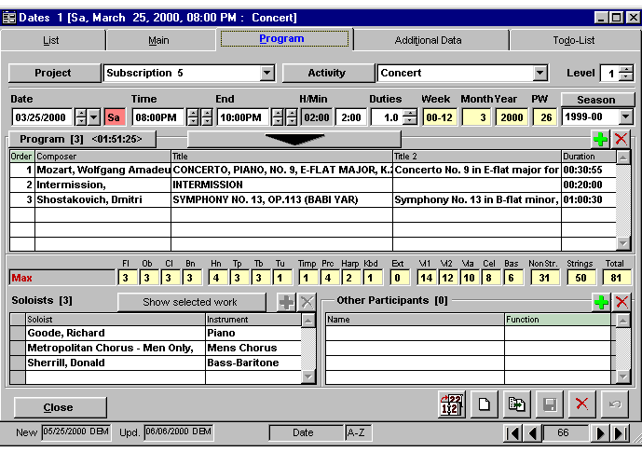
The Program Grid in the middle of the screen contains all the works performed as part this activity.

The number in square brackets after the word “Program” at the top left of the grid indicates the number of works (including intermission(s) and encores) scheduled for this activity. The number in the triangular brackets indicates the total program duration, including intermission(s) and encores.

The Program Grid displays the actual works on the program. The Grid columns are labelled:

ORDER - Note that the Order column heading is light green. This indicates that you may edit the contents of this column to re-order the works in the program (including intermission(s) ). To change the program order of a work, simply highlight the number and re-type the new order number. The other works will shuffle to accommodate your change.

TITLE and TITLE 2 – The American Symphony Orchestra League established a convention for the OLIS™ software program in which any composition can have has two distinct titles. Title (or Title 1) indicates the master or reference title used by the system. Title 2 indicates the way in which the Title should appear when printed. OPAS conforms to this and other American Symphony Orchestra League OLIS™ standards.

DURATION – The length of the work. This can either be a calculated sum of the individual movements, or a number you enter.

You can select any single work on the program by selecting it within the Grid. A selected work is highlighted in yellow.

Just above the Program grid is a large arrow. Clicking this arrow enlarges the Program Grid so that it occupies the entire lower portion of the screen. This feature enables you to see the entire program for exceptionally long programs (Pops programs, for example).

The right portion of the grid contains a green “+” and a red “x” button. To add a work to the concert program, click the green “+” key. To remove a work from the program, click the red “x” key. This convention is used throughout all grids in OPAS.

Instrumentation information for this activity appears beneath the Program Grid. As you highlight individual works in the Program Grid, this instrumentation data changes according to the work selected. If you float the mouse cursor over any specific instrument group (Flutes), the exact instrumentation pops up (1,2,p). To see the maximum instrumentation (both orchestra and soloists) for the Activity, click the button that says “Show All” at the top of the Soloist Grid. The title of a work is replaced with the word “Max” in red, and the figures indicate the maximum numbers of musicians needed for all works on the program.
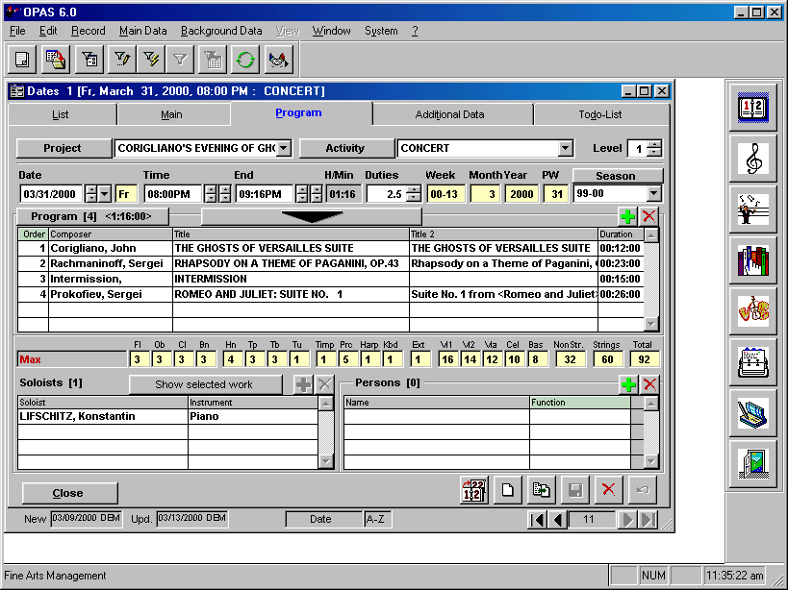

The Soloist Grid in the lower left hand corner of the screen displays all the artists or ensembles performing on this concert. Because a Soloist (or choir/ensemble) performs on a specific work (or works), that soloist must be assigned to a specific work. Therefore, you must first select the desired work in the Program Grid (highlighting it in yellow) and then assign the soloist. You will add and remove Soloists using the green “+” and red “x” buttons. You can assign any number of soloists to any number of works in the program.

Clicking the “Show All” button at the top of the grid will show all the soloists engaged for this program, regardless of the work on which they perform.

The Other Participants Grid in the bottom right of the screen operates in the same way as the Soloists grid. The difference is that “Other Participants” are assigned to the entire Activity whereas “Soloists” are assigned to a specific Work or Works within the Activity. Therefore a Soloist would perform on the Mozart concerto, but a Host or Master of Ceremonies would be assigned to the entire Concert.

You can use this feature to indicate:

- Choral Conductors or other Conductors
- Masters of Ceremony
- Artists who perform between the works on a Program
- Artists who are attached to all works on the program (solo recitals)

You add these just as you do soloists - click the green “ + “ button and select the desired entity from the list. The list you will see contains all the entities in your OPAS Address Book. This allows you to add anyone - a board member, a publisher, even another orchestra. Once added, you can change the Function of the individual or group by clicking the Function column of the Grid. Note that this column has a light green heading, and when you click in the box, a drop-down arrow appears.

One of OPAS’s most significant features is that it allows you to change any of the details of a specific piece of music only as they pertain to a specific activity, be it a concert, rehearsal, audition, recording session, etc. This means that although the Franck Symphony in d minor has three movements, you can choose to perform only movements 1 and 2 at a concert. You can also choose to replace the 2 Cornets in the Massenet with 2 trumpets, again, only for this concert. To edit these details, you would click the “Program” button just above the list of works to open the Instrumentation tab and make any necessary changes. More information on this appears below.

ADDITIONAL DATA TAB

OPAS gives you the ability to create and store your own information for each of your Orchestra’s different Activities; information that is not already contained on the Main or Program tabs. For example, you may want to indicate if a concert was recorded or broadcast, record the estimated and actual attendance, note weather conditions or the corporate sponsor, etc. Similarly, you can record the names of Jurors for Auditions, the names of Stage Managers for Run-Out concerts, etc. Each different type of Activity can have its own set of Additional Data.

To set the Additional Data for a specific activity type, choose the Background Data menu item along the top of the OPAS screen, and then choose Activities from that list (about half-way down the list)

You will see a List of all the different Activities in the database. If you choose Concert, and click the Add. Fields tab , this screen will be displayed:
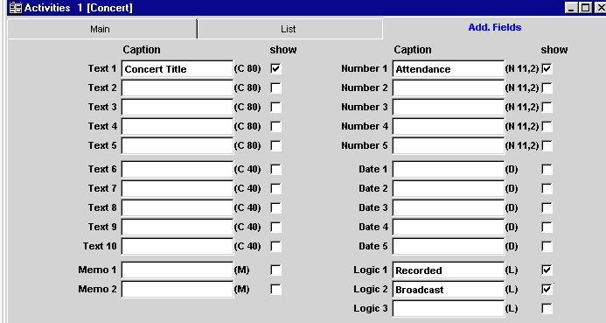

This screen indicates the data fields you can add to OPAS, and reveal on the Additional Data Tab.

The fields are:

Text 1 through Text 5 – These are text fields of up to 80 Characters in length (including spaces)

Text 6 through Text 10 – These are text fields of up to 40 Characters in length (including spaces)

Memo 1 and Memo 2 – These are two memo fields that will hold an unlimited amount of text

Number 1 through Number 5 – These are number fields and will always be stored in decimal format (so you can record financial information). You can have up to 11 digits.

Date 1 through Date 5 – These are date fields in the format mm/dd/yy

Logic 1 through Logic 3 – Logic Fields are yes/no fields and will be represented by check boxes

The Caption is the label that will appear both on the OPAS screen and on any data export.
Show indicates whether or not the field will appear on the OPAS screen (this allows you to have unused fields not appear).

Click the Save button to save your work

The next time you work in the Dates Section and choose any Activity that is a concert, the Additional Data Tab will reflect the data fields that you added. Note that these fields do not appear when you choose any Activity other than “Concert”

TO-DO LIST TAB

OPAS gives you the ability to create To-Do lists or Task Lists for any Activity in the Dates Section. As the name implies, the To-Do list organizes the myriad production details required for concerts or rehearsals, and the status of each individual item.

OPAS’ To-Do List is extremely flexible, and the process for setting up a To-Do List is:

- Create the Status Levels that will be used for the items on your list
- Create the List itself and organize the List(s) into Templates so you can assign all the items on that list at once
- Assign the Template(s) to your Activities

(1) Create the Status Levels

From the Main Screen, choose Background Data 2 | Todo-List Job Status

The window shown below will open, and it is from here that you create the various Status(es) you will use to assign to your tasks.

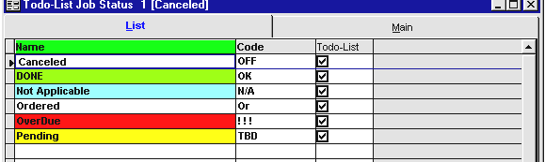
Each Status on your list will have its own code and color. Create statuses by clicking the “New” button in the lower right-hand corner (or by pressing the “ CTRL “ and “ N “ keys on your keyboard simultaneously). Make sure each Status you create has the check mark in the To-Do List box so that it will appear on subsequent lists.

(2) Create the Items on the To-Do List and the To-Do List Templates

From the Main Screen, choose Background Data 2 | Todo-List Templates. The Main Tab of this section displays the following window:
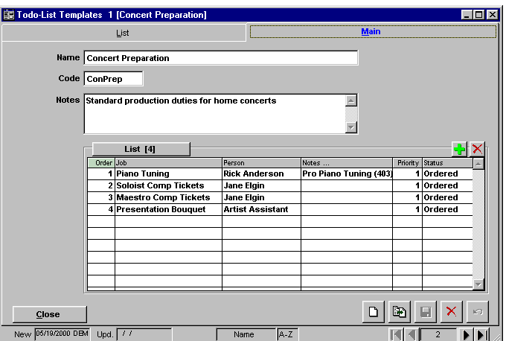
The template shown here organizes the items on your to-do list according to different categories. You will create your own templates corresponding to your Orchestra’s needs in any or all areas of Production (Concert Production, Run-Out Concerts, Audition), Repertoire (Score Distribution), or Administration (Contract processing).

The top portion of the screen contains the Template information:

Name – The name of the To-Do List Template
Code – An abbreviation or short-hand code for the Template Name
Notes – Any text or description of the Template

The bottom grid contains the actual To-Do List items. Click the green “+” icon at the top of the grid to display this window and create the actual tasks:

Job The task itself. Strive for consistency with Job Names (for example, always use “Piano Tuning” and not sometimes “Piano Tuning” and sometimes “Tune Piano”). This will make your master list of To-Do items much easier to sort and examine)
Code An abbreviation for the task.
Person The staff member responsible for the execution of this task. Again, be consistent within whatever name convention or syntax you decide to create
Priority The default priority number assigned whenever the task itself is assigned. “ 1 “ is the default, but you can put in any number you wish. Priority numbers are 0 through 9.
Notes Description or notes about the task
Status The default status assigned whenever the task itself is assigned. This list is comprised of the items you created in Step 1

Order You can re-order the tasks on this list simply by typing in new numbers in the column.

(3) Assign the To-Do Templates to Concerts or other Activities

To assign this template and list of items to a concert, click the To-Do List Tab in the Dates section.
Click the Down-Arrow next to the Templates field to select any of the templates you have created.
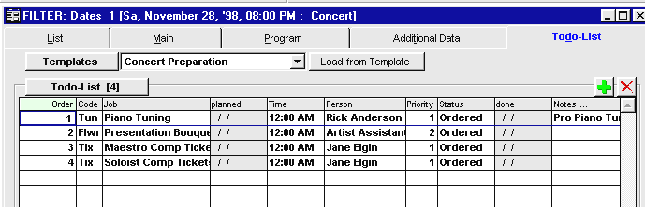
Then click the Load from Template button, and your To-Do list will be filled in, using the order and defaults set up on that list.

All To-Do items are loaded at once and you can use the navigation buttons in the lower right corner to scroll through all your items.

Finally, to track the dates and/or change the status of any item, simply double-click on it within the To-Do List Grid:

Planned – This is the date the task was assigned
Job, Person, Priority, Status and Notes – these items were all brought over from your Template but can be changed if need be for this specific Activity.
Done – this is the date the task was completed (remember to change the status to “Done” or “Completed” as well)

In this way, you can track the Status of each of your Concert Production items at a glance:

Additional points about the To-Do List feature:

- You can re-order the Columns in the To-Do List Grid. Simply click on the column heading and drag it into place.

- You can have as many different templates as you like. This gives you the ability to create specialized task lists for specific events: Outdoor concerts, Pops concerts, Tour concerts, etc.

Examples of other Operation information you could track in the To-Do List:
- Programs confirmed
- Program information distributed
- Hall schedule confirmed
- Soloist & Conductor meeting scheduled
- Commission agreements signed (if applicable)

Examples of some Repertoire-specific information you could track:
- Rental orders submitted
- Conductor Cuts/Markings received
- Scores distributed for bowings
- Marked/Bowed scores distributed
- Folders loaded

- You can assign multiple templates to any Activity. Click the down arrow as you did for the first Template, select the Template and click the Add from Template button. When you assigned multiple templates, they are combined into one master list. You can then re-order the items to suit your needs.

- If you need to add an item to the To-Do List grid that wasn’t in your template, click the Green “ + “ key at the top of the grid, and add the item you wish.

- You can include To-Do List items in any search on the database.

Viewing a Master List of all To-Do Items

Choose the Main Data menu item from the Main Screen, and choosing Todo List. That will bring up a grid that can be sorted and filtered as elsewhere in OPAS. Furthermore, double clicking on any of the To-Do items will take you to the edit Window where you can change status(es), dates, Persons, etc.
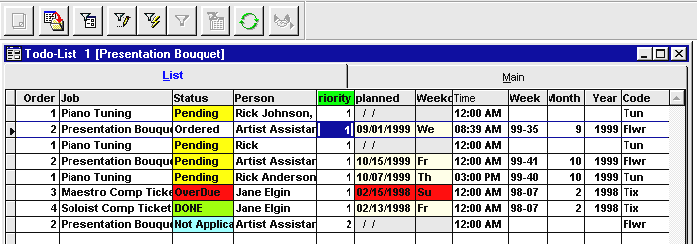

Copying Activities to create a full set of concerts.

The Dates Section allows you to easily Copy events.

Once you’ve created a concert or rehearsal, you can easily copy it to any other dates that comprise that Subscription set of activities.

To copy an Activity, click the Copy button at the bottom right of any Dates Section screen. That will bring up the following screen in which you will indicate the date(s) to which you want to copy the activity, and the attributes you wish to copy. The Activity from which you are copying is indicated in the field at the top of this window:

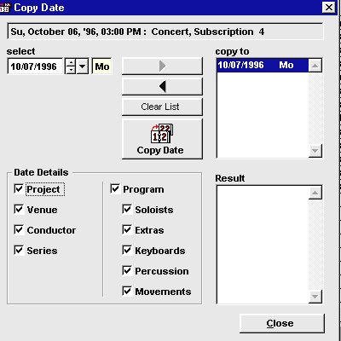
Use the drop-down menu from the “select” field to chose the date to which you wish to copy this Activity. Then click the right-pointing arrow to move that date into the “Copy to” box. You can repeat this process to select multiple dates.

At the bottom of the screen, specify which of the details or attributes of the original Activity that are to be copied

Click the Copy Date button in the middle of the screen to activate the copy function.

Click the Close button to exit this screen

This function copies all the details you specified on the Copy Date window, and all information on the Additional Data Tab.

Copying a Change in one Activity

to other Activities within the same Project

When you make a change to the details of any Activity within a Project, you are given the option to copy that change to the other Activities in that project. Adding, changing or deleting any of the fields in the Dates Section will bring up the following prompt whenever you save those changes: “Save changes to related dates?”

If you choose Yes, you are taken to this screen:
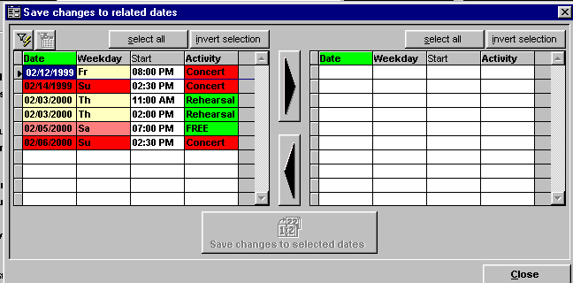
The left grid contains all the Activities that are within the same Project and the same Season as the Activity from which you are copying. All Activities are included, regarded of their type – you will see rehearsals, dress rehearsals, concerts, etc.

Choose the Activity(ies) you wish on the left side, and click the large right-pointing arrow to move it to the grid on the right side. You can also double-click on an Activity to move it.

Finally, click the “Save changes to selected dates” button to copy the changes made to your original Activity to the Activity(ies) on the right side.

Click the Close button in the lower right-hand corner of the screen to exit this window.

This procedure is followed to apply any changes across all the Activities of a Project. It applies to changes made to the Dates Tabs themselves (Main, Program, Additional Data or To-Do List), or changes to the Dates/Program Section. In this way you can easily apply changes of timing, instrumentation, movement order, etc.

Additional points about the Copy to Related Dates feature:

- Multiple changes to Activities are copied – if you change a soloist and program for a rehearsal, then choose to copy that change to all related dates, both the soloist and the program change will be copied.

- You can also “copy” deletions. If you remove a work from a program, you can copy the removal of that work to other Activities – that is, also delete the work from those programs.

- The Copy to Related Dates only applies changes that are logical. For example, if you make a change to a specific work by Mozart on a rehearsal, then mistakenly copy that change to a rehearsal that does not have the Mozart scheduled, no change will be made. . OPAS would not add the Mozart work to the second rehearsal only for the sake of making the change

Performers & Conductors

OPAS consolidates all information on the Artists and Conductors who both perform with your orchestra, and comprise your orchestra, in the Artist Section.

Artist Section

This section keeps track of all the soloists and conductors who perform with your orchestra, and the musicians who comprise your orchestra. It also contains all the Orchestras and Choirs in your database. As with the other sections of OPAS, Artists is organized by different Tabs:

- List
- Main
- Contacts / Agents
- Additional Data
- Personal Data
- Absences / Vacations
- Dates

LIST TAB

The List tab is used in all sections of OPAS, and provides a consolidated inventory of the entire section’s contents. In the Artists section, that means all the Soloists, Conductors, Orchestra Members, Orchestra Substitutes, Choirs and Orchestras in the OPAS database.

The columns on the screen contain the basic Name, Group, Instrument, and Address for each Artist. The columns can be:
- resized (float the mouse cursor between column headings and drag to the right or left)
- re-ordered (click on a column heading and drag it to the right or left)
- re-sorted (click on a column heading to sort the list by the contents of that column. The List tab sorts by Date as a default.)

The List will be used extensively to execute Searches and Filters

To see the details of any one Artist, click the mouse once anywhere in that row, then click the Main Tab at the top of the window. Or, you can simply double-click the mouse anywhere in the row.

MAIN TAB

This screen contains all the basic information about an artist. You may store as much or as little information about each artist as you wish.

Co. / Last Name
The Last Name or Organization / Company Name (in the case of a Choir or Orchestra)
First Name / Code
The Artists’ First Name and Code or Abbreviation
Name 3
An additional Name, if required
Name 4
An additional Name, if required
Address 1 / Address 2 / City / State / Zip / Country
The Personal Address of the Artist. (For Soloists and Guest Conductors, you may only know the country of residence)
Title Formal Title or prefix (Dr., Ms., Maestro, etc)
Salutation
If you will run Mail Merges or create documents from OPAS, you can create a list of Salutations that are used
Notes
Is an open field for any additional information
Order The two order fields are used only for Orchestra Members or Substitutes. They are 2 fields that can be used at your discretion to indicate the Artist’s seating order. For example, the left field could indicate the stand and the right field the chair at that stand
Mark Used to Temporarily mark a field for use during Searches and Filters
Activated
This toggle allows you to mark an Artist as “inactive”; you can tailor searches and filters to avoid all artists thus marked, yet you do not need to delete the record from the database.

GROUP GRID
This Grid indicates the Address Group(s) to which the Artist belongs. Any Artist can belong to more than one group – a Conductor could also be a Soloist, for example – and you add and remove groups with the green “ + “ and red “x” buttons. The group highlighted in yellow is considered the Artist’s Main Group. You can make any group the main one by selecting it in the grid, and clicking the Set to Main button.

CONTACT NUMBERS GRID
This grid contains all the phone / fax / email contact numbers for the Artist or Choir / Orchestra. To add a contact number, click the small “blank page” icon. You will then enter the Number (or email address), the Type of number it is, and any short descriptive text (Home, Cell, Office, etc.)

INSTRUMENTS GRID
This grid lists the instrument(s) played by the Artist. In the case of a chorus, it indicates the type of chorus (SATB, Children’s Chorus, etc). Add and remove instruments with the green “ + “ and red “x” buttons. The instrument highlighted in yellow is considered the Artist’s Main Group. You can make any instrument the main one by selecting it in the grid, and clicking the Set to Main button.

FUNCTIONS GRID
This Grid is used in OPAS EXTENDED – it indicates salary or per-service pay rate assigned to this artist

CONTACTS / AGENTS TAB

The Contacts/Agents tab organizes the Agents for a soloist, the Orchestras to which an Artist may belong, Conversations or Contacts you may have with the artist, additional Residences, and Contact People (publicists, etc) for the Artist. Each set of data is kept in its own Grid.

CONTACTS GRID -
This grid stores any series of contacts you may have had with the Artist. It could track discussions regarding soloist appearances, orchestra member hiring, etc. For each entry in the grid, you will indicate its Date, Type (“P” for “Phone” or any code of your own choosing), and a Text description or note.

ORCHESTRA GRID
This grid lists the Orchestras and/or Choruses to which this Artist belongs. If you are only storing information on your main Orchestra, this grid may be superfluous. However, you may want to track the individual members of your Pops Orchestra, Training Orchestra, Baroque Orchestra, etc. You may also indicate in this grid any other orchestra to which this Artist belongs (or belonged).

CONTACT PERSONS GRID
This grid contains the Names and contact information for the people with whom you work regarding this artist. This information will be used almost exclusively with Soloists and Guest Conductors. You can list managers, publicists, servicing agents, etc. In many instances, you will use this grid to indicate the individual people at the Agency (see below) who are responsible for this Artist.

To add a new contact person, click the green “+” icon to bring up this screen. The fields match those on the Artist main tab.

RESIDENCES
This grid stores any other addresses you wish to keep for the Artist.

AGENTS
This grid contains the Name, City and Capacity of the Artists Agent. Click the green “+” icon to display a list of Agencies from which you can choose. In the Capacity field, you can type the relationship of the Agent to this Artist. This enables you to specify “Booking Agent”, “Personal Manager”, “Publicist”, “Producer”, etc.

PERSONAL DATA TAB

The Personal Data Tab stores information for Artists who are primarily members or substitutes in your Orchestra. These fields are self-explanatory and can be used (or not used) to the extent you wish.

ABSENCES / VACATIONS TAB

The Absences / Vacations Tab is primarily intended for your Orchestra members and substitutes. This grid stores planned absences for Artists. It allows you to record future leave, sabbatical, etc. If you use OPAS EXTENDED, this information will be referenced when you schedule personnel.

There can of course be many different reasons a musician is absent. You will create a list of these Absence Types, and assign them as needed. To create Absence Types, choose the Background Data 1 menu item and then select Absence Types…, at the bottom of the list:

This screen lists all the various types of (or, if your prefer, potential reasons for) a musician’s absence. Each different type has a Name, Code, Notes and Colour which will be used in the Absence / Vacation grid.

To assign a specific absentee period to an artist, go to the Absences / Vacations Tab for that artist and click the green ”+” icon at the top of the grid. This will produce a window in which you choose the Absence Type you wish, the Start and End dates, and any Text or Notes regarding the absence. Then click the green OK button to save your entry and return to the grid.

TIP: You can also use this grid to plan and track Guest Artist unavailability for coming seasons.

DATES TAB

Every time a soloist, conductor, chorus or orchestra is assigned to a concert, rehearsal or other service in the Dates section, that activity will be listed on this screen.

The pertinent information regarding each of these activities is contained in columns. Each of these columns can be:

- resized (float the mouse cursor between column headings and drag to the right or left)
- re-ordered (click on a column heading and drag it to the right or left)
- re-sorted (click on a column heading to sort the list by the contents of that column).

By default, this screen sorts in Reverse Chronological order. Most recent activities are listed first. This provides you with a comprehensive Performance History for this Artist.

Address Book

In addition to Artists, Conductors and Choirs/Orchestras, you will need to store and organize many other entities in OPAS. These are kept in the Address Book:

This section keeps track of all entities in your database, and can include Venues, Publishers, Artist Managers, Board Members, etc.

As with the other sections of OPAS, the Address Book is organized by different Tabs:
- List
- Main
- Contacts / Agents
- Additional Data

LIST TAB

The List tab is used in all sections of OPAS, and provides a consolidated inventory of the entire section’s contents. In the Address Book section, that means all the Venues, Publishers, Agents, etc. in the OPAS database.

As the List Tab demonstrates, the Address Book contains every entity in your database, even those that are also in the Artists section. The Address book consolidates all entries that belong to any Address Group.

MAIN TAB

This screen contains all the basic information about the entity. You may store as much or as little information about each entity as you wish.

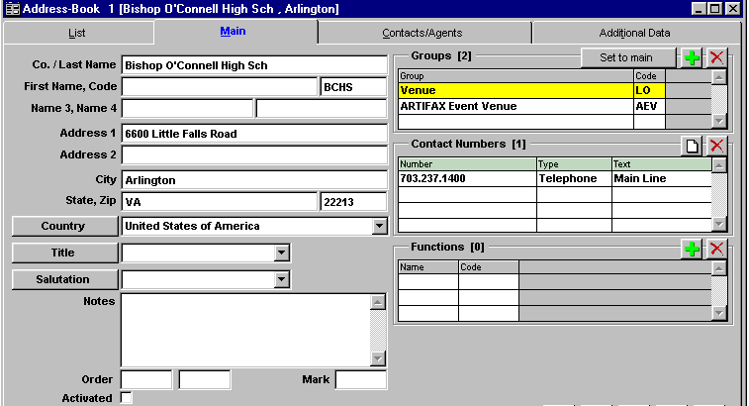
Co./Last Name
The Company Name (or Last Name of a person)
First Name/Code
The First Name and Code or Abbreviation for the Entity
Name 3
An additional Name, if required
Name 4
An additional Name, if required
Address 1/Address 2/City/ State/Zip/Country
The business or personal address
Title Formal Title or prefix (Dr., Ms., Masestro, etc)
Salutation If you will run Mail Merges or create documents from OPAS, you can create a list of Salutations that are used
Notes An open field for any additional information
Order The two order fields are used only for entities that are Orchestra Members or Substitutes. They are 2 fields that can be used at your discretion to indicate the Artist’s seating order. For example, the left field could indicate the stand and the right field the chair at that stand
Mark Used to Temporarily mark a field for use during Searches and Filters

GROUP GRID
This Grid indicates the Address Group(s) to which the entity belongs. Any entity can belong to more than one group - you add and remove groups with the green “ + “ and red “x” buttons. If there is more than one Group listed, the group highlighted in yellow is considered the entity’s Main Group. You can make any group the main one by selecting it in the grid, and clicking the Set to Main button.

CONTACT NUMBERS GRID
This grid contains all the phone / fax / email contact numbers for this Address Book entry. To add a contact number, click the small “blank page” icon. You will then enter the Number (or email address), the Type of number it is, and any short descriptive text (Home, Cell, Office, etc.)

FUNCTIONS GRID
This Grid is used in OPAS EXTENDED – it indicates salary or per-service pay rate assigned to this entity if it is an Artist

CONTACTS / AGENTS TAB

The Contacts/Agents tab organizes a variety of information for each entity. Because the Address Book stores many different kinds of entities (a variety of Address Groups), you may use this screen in a variety of different ways.

CONTACTS GRID
This grid stores any series of contacts you may have had with the entity. It could track discussions, confirmations, document exchanges, etc. For each entry in the grid, you will indicate its Date, Type (“P” for “Phone” or any code of your own choosing), and a Text description or note.

ORCHESTRA GRID
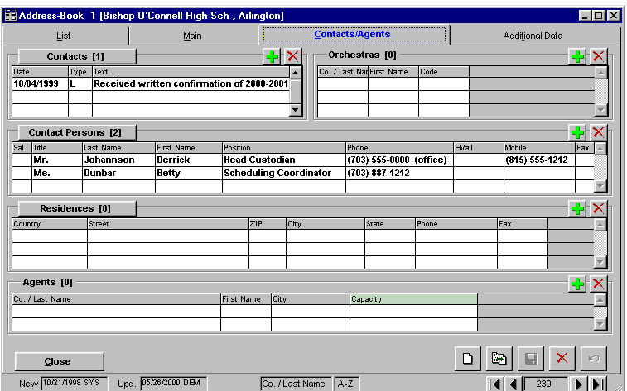
If the entity in question is an Orchestra Member or Substitute, this grid lists the Orchestras and/or Choruses to which an Artist belongs.

CONTACT PERSONS GRID
This grid contains the Names and contact information for the people with whom you work regarding this entity. To add a new contact person, click the green “+” icon to bring up this screen. The fields match those on the Address Book main tab.

RESIDENCES
This grid stores any secondary addresses you wish to keep for the entity.

AGENTS -
You will use this grid for individual artists, and Publishers. It contains the Name, City and Capacity of the entity’s Agent. Click the green “+” icon to display a list of Agencies from which you can choose. In the Capacity field, you can type the relationship of the Agent to this entity.

Composers & Repertoire

This section is the heart of OPAS. These sections all work together to provide a consolidation of your orchestra’s library. Composer and Repertoire Information in OPAS is divided into six sections:

The Composer section shows the biographical information on composers in your database.
The Works section displays the details of all works in your database.
The Publication section assigns Publishers in your database to Works in your database.
The Perusals section tracks the whereabouts of scores you have borrowed.
The Rentals section tracks the whereabouts of scores you have rented.
The Library section stores all the pertinent information regarding scores that you own.

COMPOSER SECTION

This section contains all the basic information on Composers. Once you use this section to enter a composer into your OPAS database, you can assign that composer to compositions or works in the database (see the next section).

LIST TAB

The List tab is used in all sections of OPAS, and provides a consolidated inventory of the entire section’s contents. In the Composer section it displays the Composer’s Name, Birth and Death Dates, and Abbreviation or Code. To see the details of any one Composer, click the mouse once anywhere in that row, then click the Main Tab at the top of the window. Or, you can simply double-click the mouse anywhere in the row.

MAIN TAB

This screen contains all the basic information regarding a Composer.

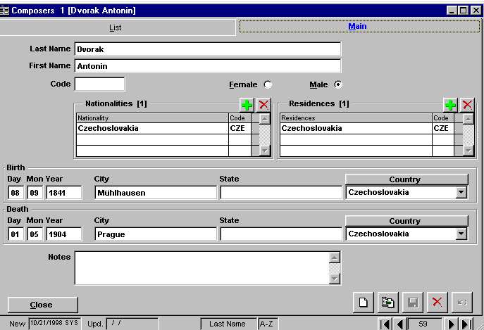
The top portion of the screen indicates the Composer’s First and Last Name, an abbreviation, initials or Code for the Composer, and the composers Gender. The middle portion of the Screen contains two grids. You will use these to indicate the Nationality and any Residences of the Composer. The bottom portion of the screen records the Birth and/or Death information for the Composer.

If you wish to keep further information on living composers – address, publisher, manager, etc. – then you will make a new record of that Composer in the Artist Section, in addition to the record in the Composer section. You will in fact have two separate OPAS entries for that one person. This is the one instance in OPAS where this occurs, and is necessary for two reasons: (a) the information kept for Composers is distinct from that information kept for other entities, and (b) Works in the database look to the Composer section for an author, not the Artist section.

WORKS SECTION

You will create an Orchestral Work in the database with:
- a unique Composer
- unique Movement Markings and Timings
- unique Instrumentation

Once a work is created, it can then:
- Have one or more Publishers
- Become part of your Orchestra’s Library
- Have Rental score information assigned to it
- Have Perusal score information assigned to it
- Be assigned to any Performance(s)

Once a work is assigned to a performance, the Instrumentation, Movement Markings, Secondary Title and Timings can be altered only as they pertain to that performance.

LIST TAB

The List tab is used in all sections of OPAS, and provides a consolidated inventory of the entire section’s contents. In the Works section it displays the Composer, Main Tile, Key, Genre, Style, Duration, Date, and Code for each Composition in the OPAS database.

MAIN TAB

This screen keeps all the basic data for each Work or Composition in the database:

Composer The Composer for this Work. Names in this drop-down list are read from the names in the Composers section in OPAS. (see the previous section, Composers, for more information). This field is highlighted in yellow, indicating that it cannot be edited.
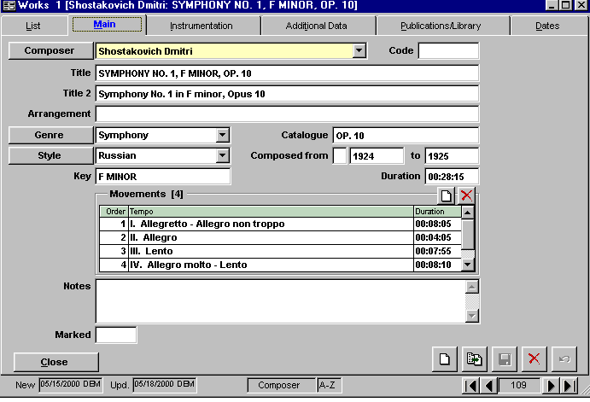
Title The main Title of the composition. This is the title by which you will perform the majority of your Searches and Filters in OPAS, so it is strongly recommended that you employ strict consistency in recording the title of works. It is an OLIS™ convention that this title be recorded in all Capital letters. The demonstration database that comes with OPAS exhibits many of the other conventions used for the Titles of works.
Title 2 This is the title of the work as you will wish it to appear on printed programs and reports. You can indicate an alias, or common title, for the work, spell out “opus” and other words, etc. It is an OLIS™ convention that any portion of the title that is to appear italicized is enclosed in carats. For example: <Academic Festival Overture> . It is not necessary to make a distinction between Title and Title 2 – for many works they may be exactly the same.Other examples of the difference between Title and Title 2 for individual works:

TITLE: CTO., VIOLINS (2), D MINOR, BWV 1043
TITLE 2: Concerto in D minor for Two Violins and String Orchestra, BWV 1043

TITLE: CANDIDE: OVERTURE
TITLE 2: Overture to <Candide>

Code An internal abbreviation or shorthand for this Work. If you convert an existing OLIS™ database, the Work’s OLIS™ index number is stored here.
Arrangement The name of the Work’s Arranger or name of the Arrangement.
Genre Commonly used to record the musical forces or composition’s genre (an OLIS™ convention)
Style The nationalistic style of the Work (an OLIS™ convention)
Catalog The Work’s catalog number – opus number, BWV number, K. number, etc.
Composed From / To
These three fields store: (a) a composition date indicator such as “c.”, “?”, etc. (b) the beginning year of composition (if the work was composed over a span of more than one year), and (c) the final year of composition (if the work was composed over a span of more than one year).
Key The Key of the Work

Duration field and Movements Grid

The Movement grid contains the Name of each Movement, its Duration, and the Order in which it is performed. The Name of the Movement should be typed as you wish it to appear on a printed program or report. This is why you will often see the number of the movement incorporated into its name (“III. Lento”). The Duration of each movement in the grid is stored in an hour:minute:second format.

You can record as many movements as you wish. To add a movement to a work, click the “Blank Page” icon at the top of the grid: Select a movement and click the red ”x” button to remove it from the Work.

The Duration field at the top of the Movement Grid automatically sums the duration of each movement within the work. You can also type a Duration amount of your own. For example, if the sum of all movements in a work is 27:58, you could instead indicate that the work is 28:00 minutes long.

Notes – is an open field for any additional information
Mark – Used to Temporarily mark a Work for use during Searches and Filters

Instrumentation Tab

This tab indicates the Instrumentation required for a Work.
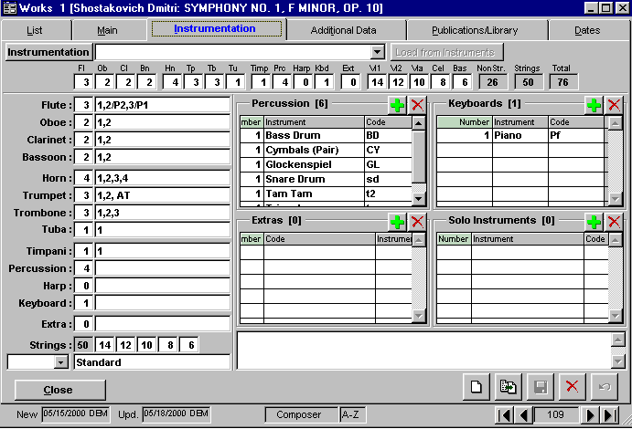
Instrumentation / Load from Instruments
The Instrumentation drop-down field allows you to choose from a pre-defined list of Instrumentation configurations you create in OPAS. These Instrumentation configurations can be genre or period specific (“Classical”, “Baroque”, “Pops”) or can be specific to your own orchestra.

Individual Instruments
The left field for any single instrument indicates the total required for the work. The right field indicates the breakdown or configuration of that instrument.

Strings
As with the Instrumentation drop-down list at the top of the screen, you can build a pre-defined list of String Complements, and assign them to a Work using the drop-down arrow. As with Instrumentation, these string complements can be either genre-specific, or specific to your orchestra.

Percussion / Keyboard / Extra / Solo Instruments Grids
These four grids store the information indicated by their titles. With each, you click the green “+” key to add an instrument, and the red “x” to remove one. With each entry in the grid, you can indicate the Number required for the work – the default number is “1”, but you can change it to whatever number you wish.

Notes The large field beneath the Extra and Solo Instruments grid can be used to store further information regarding the Work’s instrumentation (indicate the location of offstage instruments, description of unusual instruments, optional doublings, etc.)

Additional Data Tab

This tab stores Additional Data regarding the Work.

Commission The entity (or entities) who commissioned this work
Sourcetext The source of the Work’s text or lyric
Intermission A check in this box indicates that this work is considered an intermission. This distinction is used almost exclusively in the printing of reports and the export of data. For example, if you were to print the instrumentation for a concert program, you would obviously want to exclude any intermission.
Regular Work Similar to the “Intermission” flag, a check in this box indicates the composition is “regular.” Un-checking this field gives you the ability to further segregate works and refine searches and filters.
Themes Are further indications or distinctions of a Work’s genre or type. For example, a Work might be of the Genre “Narrator and Orchestra” and of the Style “American.” You may want to further indicate that the work is a “Children’s” work. Click the green “+” and choose from the available list to add Themes to this work.
Languages To indicate the language of sung or spoken text in a work, click the green “+” to choose from the list of available Languages
Perf. Rights To indicate any ASCAP, BMI or other performance rights that are associated with the performance of this work, click the green “+” to choose from the list of available Performance Rights Associations.
Premieres This grid enables you to record the various premieres of a given work. For each you indicate the Premiere (World, U.S., North American, etc), the Orchestra that gave the premiere (your orchestra or another), and the Conductor / City / Venue and Date.

Publication / Library Tab
The detailed information regarding Publishers and Library Holdings for each work are covered in their respective sections. This tab provides a summary of that information for the current work. The top, Publications, grid indicates the Publisher, Reprint scores, and availability for published scores of this Work. The bottom, Library, grid indicates the specific catalog number, edition and Publisher of the Work if it is contained in your permanent holdings.

Dates Tab
Each time this work is assigned to a Date or Activity, that Activity is indicated here, thereby revealing a comprehensive history of each work’s performance by your orchestra. The basic performance information (Conductor, Date, Venue, etc.) is stored in each column. As with the List Tab, these columns can be resized, re-ordered and re-sorted. The Dates Tab is by default sorted in reverse-chronological order (most recent performances at the top).

PUBLICATION / PUBLISHER SECTION

Music Publishing companies are created in the Address Book section of OPAS. You will access this section by choosing the Main Data menu item and selecting Publications… As mentioned at the beginning of the Works section, each Work can have one or more publishers assigned to it.

LIST TAB

The List tab is used in all sections of OPAS, and provides a consolidated inventory of the entire section’s contents. In the Publications section it displays the Composer, Tile, Publisher and Availability for each distinct publication of a work. As you can see, any single work can have multiple Publishers. This will mean separate Publication Records and separate lines on the List Tab.

MAIN TAB

This screen keeps all the basic Publication Data for each Publication Record (that is, each distinct Publication of a single work):

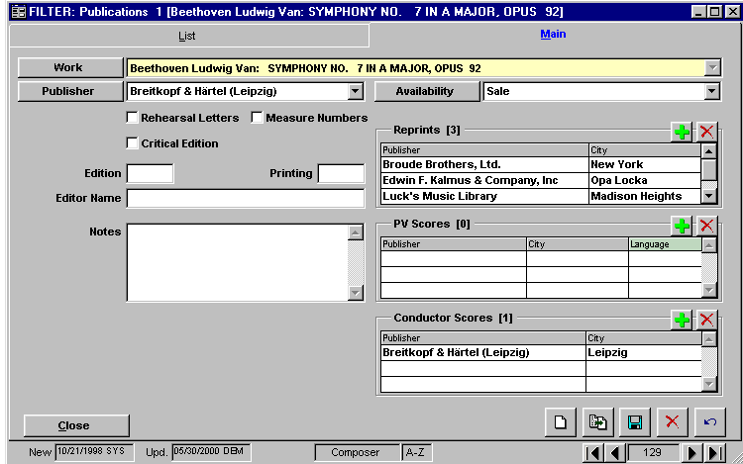
Work The Composer and Title of the Work. Note that this field is highlighted in yellow, indicating that it cannot be edited.
Publisher
The Publisher of the work. Each Publishing Company is its own entity, created in the Address Book section of OPAS
Availability
Indicates if the score is available for Sale, Rental, Not Available, Out of Print etc.
Rehearsal Letters / Measure Numbers / Critical Edition
You will check each box to indicate its relevance to this Publication
Edition / Printing
Each of these fields is a number field, and indicates the Number of this Publication’s Edition and/or Printing.
Editor Name
The name of the editor, if known
Notes Any description or further information regarding this Publication.
Reprints Grid
This grid lists the different Reprint Scores associated with this Publication record. Click the green “+” to add a new reprint score publication. Select a line in the grid, then click the red “x” button to remove a record.
P/V Scores Grid
This grid lists Piano/Vocal scores associated with this Publication record. Click the green “+” to add a new Publisher of a piano/vocal score. For each piano/vocal score you can indicate the Language from the Drop-Down list in that column. Select a line in the grid, then click the red “x” button to remove a record.
Conductor Scores Grid
This grid lists the different Conductor Scores associated with this Publication record. Click the green “+” to add a new Publisher of a conductor score. Select a line in the grid, then click the red “x” button to remove a record.

PERUSALS SECTION

Perusal Scores are those scores that are borrowed from an outside source. Most often, this is a Publisher, but it can also be another orchestra, library, university, etc. Music Publishing companies are created in the Address Book section of OPAS. You will access the Perusals section by choosing the Main Data menu item and selecting Perusals…

LIST TAB

The List tab is used in all sections of OPAS, and provides a consolidated inventory of the entire section’s contents. In the Perusals section it displays the Composer, Tile, Publisher and Agent for score ordered, the Project for which the score is considered, and the individual who originally Requested the score.

To see the details of any individual Perusal order, click the mouse once anywhere in that row, then click the Main Tab at the top of the window. Or, you can simply double-click the mouse anywhere in the row.

MAIN TAB

This screen keeps all the basic information required for the order of a Perusal score:

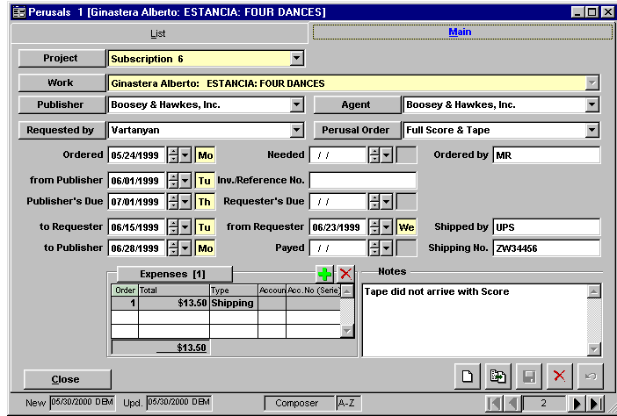
Project
The project for which this score is ordered.
Work The work itself. To select the work, you will first select the Composer (by last name) on the left side of the split window. Once the Composer is chosen, the list of works in the OPAS database by that composer will appear on the right side of the split window.

Publisher
The publisher(s) of this work. Only Publishers you have previously assigned to this work will appear in the drop-down list.
Agent Any Agent(s) assigned to the Publisher
Requested by
The individual in the Orchestra who requested the score. An entity must belong to the Address Group Requester to appear in this drop-down list.
Perusal Order
The specific items ordered for perusal.
Date Fields
The section of date fields enables you to record the pertinent dates regarding the receipt, distribution and return of the score

Expenses Grid
This grid records all the expenses associated with the receipt and return of this item. Click the green “+” button to add an expense via the Expenses window:

RENTAL CONTRACT SECTION

Rental scores are those scores that are rented from a Publisher. Music Publishing companies are created in the Address Book section of OPAS. You will access the Rental Contracts section by choosing the Main Data menu item and selecting Rental Contracts…

LIST TAB

The List tab is used in all sections of OPAS, and provides a consolidated inventory of the entire section’s contents. In the Rental Contracts section it displays the Composer, Tile, Publisher and Agent for score ordered, the Project for which the score is considered, and the Date the score was ordered.

To see the details of any individual Rental Contract, click the mouse once anywhere in that row, then click the Main Tab at the top of the window. Or, you can simply double-click the mouse anywhere in the row.

MAIN TAB
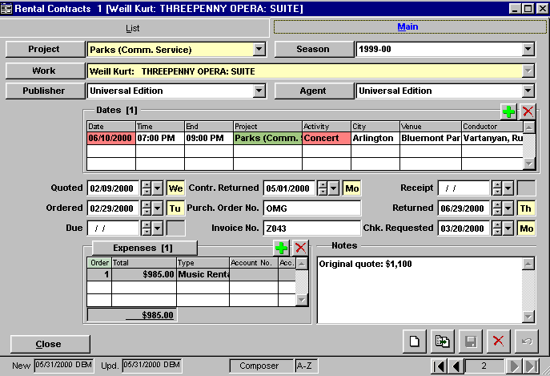
This screen keeps all the basic information regarding a Rental Contract:

Project The Project for which this score is rented
Season The Season for which this score is rented
Work The Work itself. To select the work, you will first select the Composer (by last name) on the left side of the split window. Once the Composer is chosen, the list of works in the OPAS database by that composer will appear on the right side of the split window.

Publisher
The publisher(s) of this work. Only Publishers you have previously assigned to this work will appear in the drop-down list.
Agent Any Agent(s) assigned to the Publisher
Dates Grid
The Date Grid stores all the Activities within the Project for which this score is required. This enables you to select only the Performances within a Project, should you wish. To add a date, click the green “+” at the top of the grid. You will be shown a list of all dates (a) that are part of the project/season combination currently active, (b) that have this work assigned and (c) for which a rental contract has not yet been assigned.
Date Fields
The section of date fields enables you to record the pertinent dates regarding the receipt, distribution and return of the score, the receipt and return of the rental contract, and the date you request the check from your Accounting department.
Expenses Grid
This grid records all the expenses associated with the rental of this score. Click the green “+” button to add an expense via the Expenses window:

Library and Permanent Holdings

The Library Section of OPAS organizes all Works in the database that you own, and/or are part of your Orchestra’s permanent collection. As with the Publications section, any single Work in the database can appear many times in the Library section. You may own multiple copies of a Work, or own different editions or publications of a Work.

LIST TAB

The List tab is used in all sections of OPAS, and provides a consolidated inventory of the entire section’s contents. In the Library section it displays the Composer, Tile, Publisher and Catalog Number for each score, and indicates if the Parts for that score are in your library.

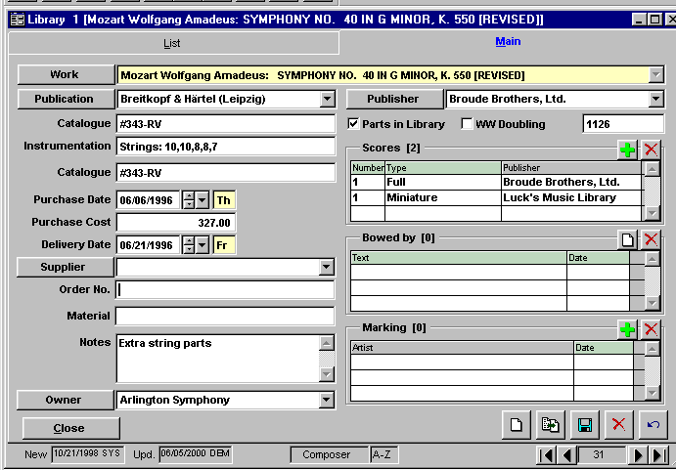
MAIN TAB

This screen keeps all the basic information regarding a score and parts in your Library:

Work The Composer and Title of the Work
Publication/Publisher
The Publication Record associated with this Work and the Publishers associated with this work.
Catalog The internal shelf or catalog number for this score
Parts / WW Doubling
Indicates if the Parts are in the Library and Woodwind doublings
Unmarked This field is used to store the Library ID number if your data is converted from OLIS™
Instrumentation
An optional field to store instrumentation / string complement information
Purchase Date / Cost / Delivery
Optional fields regarding the purchase of the score
Supplier The supplier of the score
Order Number
Invoice or order number from the Supplier
Material The actual materials shipped
Owner The owner of this work/score set

Scores Grid
Stores the number, type and Publisher of the physical scores on your library’s shelf. Click the green “+” key to add a new score. Indicate the number you own, the Type of score (Full, Piano/Vocal, Miniature, etc) and the Publisher.
Bowed Grid
Indicate the name of the person who marked the bowings and the date. You can add new entries by clicking the “New” icon
Marked By Grid
Indicates the Artist(s) who marked the scores.

Date Works

OPAS enables you to indicate changes to the Title, Movement(s), Instrumentation, Arrangement, and/or Timing of any Work in the Database, as that Work pertains to a particular performance.

This means that if a guest conductor takes a radically different timing for a particular work, you can indicate that timing change only for that guest conductor’s performance. Similarly, performances of single movements, excerpts of works, and reduced instrumentations can be recorded and kept, but do not affect the “master” record of the Work.

Because this section of OPAS deals specifically with the performance of a composition, it is given the name Dates/Works.

Date Works Section

There are two ways to see the Dates/Works section of OPAS:

1. From the main screen, choose Main Data, and then Dates Works . . . This will show you every piece of music as it is assigned to any rehearsal or performance in the database

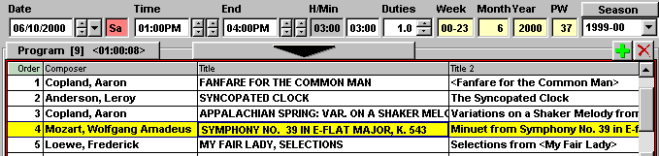
2. To see the compositions that are part of any one rehearsal or concert, click the Program button at the top of the Program Grid in the Dates section:

The examples shown here use the second method.

The Dates Works section will load all the Works (including Intermission(s) ) assigned to the current Activity. The Dates Works section is divided into three sections – the List Tab, Main Tab and Instrumentation Tab:

LIST TAB

The List tab is used in all sections of OPAS, and provides a consolidated inventory of the entire section’s contents. In the Dates Works section it displays the Composer, Tile, Publisher and Catalog Number for each score, and indicates if the Parts for that score are in your library.

To see the details of any individual composition, click the mouse once anywhere in that row, then click the Main Tab at the top of the window. Alternatively, you can simply double-click the mouse anywhere in the row.

MAIN TAB

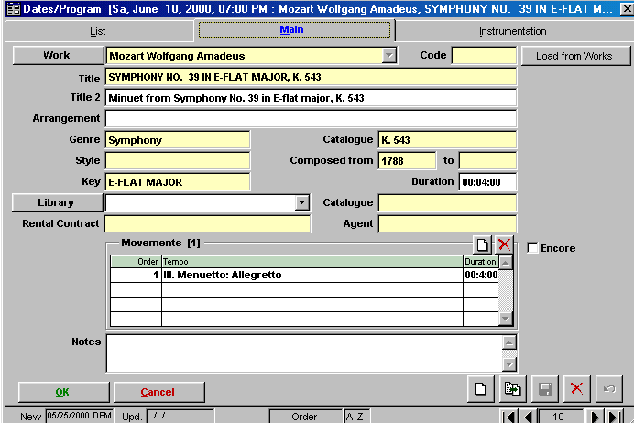
This screen shows the pertinent information for the Performance of this Work on the Date indicated in the Title Bar.

This screen is very similar to the Main Tab of the Works Section. However, many of the fields are highlighted in yellow – these indicate fields that cannot be changed. You can edit all fields in white to better reflect the performance of this work on this date.

In this example, the orchestra performs only the Third Movement of the Mozart Symphony No. 39. OPAS allows you to indicate all the changes in the work and instrumentation that reflects this, without altering the original, “master”, record of Symphony No. 39 in the Works section.

You are able to change/delete/edit the following:

Title 2 - the Title as you wish it to appear on Printed materials
Arrangement – the Arranger or particular Arrangement of the work
Duration – the duration of the work for this performance. This enables you to keep track of different conductor’s timings of works, and/or to indicate changes in timings when repeats are (or are not) taken.
Library – if this work is part of your permanent holdings, you can indicate the Publication (edition) used for this performance
Movements – you can add, remove, edit, re-order, or in any other way change the movements of a Work as they pertain to this Performance
Encore – indicates the work was performed as an Encore on this Date
Notes – any performance-specific text or notes.

Load from Works – this button will load all pertinent information from the entry of this composition in the Works section (that is, the “master” or original composition as it appears in the OPAS database). This, in effect, restores “Default” values.

INSTRUMENTATION TAB

This screen shows the pertinent Instrumentation information for the Performance of this Work on the Date indicated in the Title Bar.
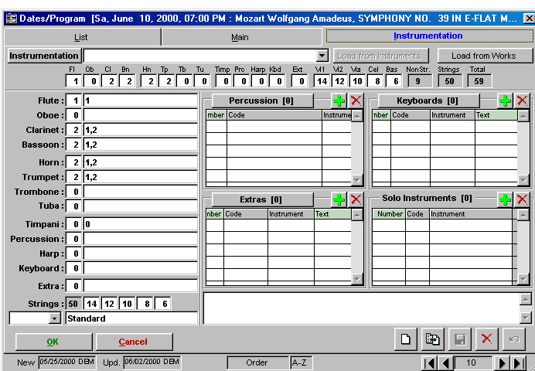
This screen is very similar to the Instrumentation Tab in the Works section of OPAS.

All fields are in white, which indicates that you can edit, add, or in any other way change the Instrumentation of this work as it pertains to this performance.

In this example, we indicated that although the Symphony No. 39 is scored for timpani, there is no timpanist required for this performance (as the orchestra is playing only the 3rd Movement).

See the section below for more information regarding instrumentation changes

Load from Works – this button will load all instrumentation information from the entry of this composition in the Works section (that is, the “master” or original composition as it appears in the OPAS database). This, in effect, restores “Default” values.

Assigning Musicians

OPAS allows you to specify the players or performers of instruments assigned in the Percussion, Extra and Keyboard sub-grids of Instrumentation pages in the Dates Works Section. This example will use a fictional composition that has two percussionists. The first plays Snare Drum and Triangle, the second plays Xylophone and Chimes.

STEP ONE – CREATING THE PERCUSSION PLAYERS

First, you must create the percussionists who will play the instruments (likewise, you’ll need to create the Keyboardists, and Extra musicians). You can create these performers with the actual names of the players in your orchestra, or use a generic “Perc. 1”, “Perc. 2”, etc.

NOTE: if you will use the Personnel Management systems of OPAS Extended, you will use the actual names of your Orchestra Members so that payroll and attendances can be properly calculated.

For Percussionists, each Artist will be of the Address Group Staff. You will assign all the instruments of the Percussion Section, so that regardless of the specific percussion instrument required for a Work, this Artist will be available to play it. You can then repeat the process for “Perc. 2” and any other Percussion Players you wish to create. The process will be the same for Keyboardists and Extra Instrument players.

STEP TWO – ASSIGNING THE PLAYERS TO WORKS IN THE DATES SECTION

Within the Dates Section, go to any Program Tab and double-click on a composition to bring up the Dates Works Section. Then click on the Instrumentation Tab to bring up this screen. Note that the Percussion, Keyboard and Extra sub-grids have a Text and Artist column. Note: you may have to resize the columns by dragging to the left in order to fit all four columns in their respective windows:

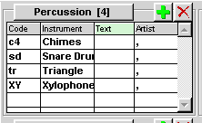
Next, assign the Percussion Instruments by clicking the green “+” key, and your Percussion sub-grid will look like this:

Note that the Artist column has commas in it, but no specific performers. To assign the artists, double-click in any of the Artist column fields that has a comma in it, and you will see window. (You will first be prompted to save your change (the change being the addition of the Percussion instruments), and should answer “yes”).
You will then be asked if you want to apply your changes to the other Dates within that Project. You can, at this point, say “No” (you can always apply your changes once the Players have been added).

Note that in the lower right-hand corner of the window is a number indicating the number of Percussion Instruments required for this work (in the case of this example, it is 4 – Chimes, Snare Drum, Triangle and Xylophone).

Simply click the drop-down arrow next to the Artist field and the names of all those Artists who have had that Percussion Instrument assigned to them will appear. In this example, the only two names that appear are “Perc. 1” and “Perc. 2”, but in your database you may have the individual Percussionists in your orchestra.

Using the navigation buttons in the lower right-hand corner, page through the four Percussion instruments, and assign the appropriate players to each.

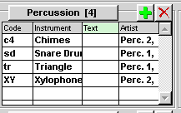
Use the Text field for a short description of the placement or tuning of the instrument, the specific mallets to be used, or other details.

When you are finished, you will return to the Instrumentation screen and the Percussion sub-grid will look like this.

